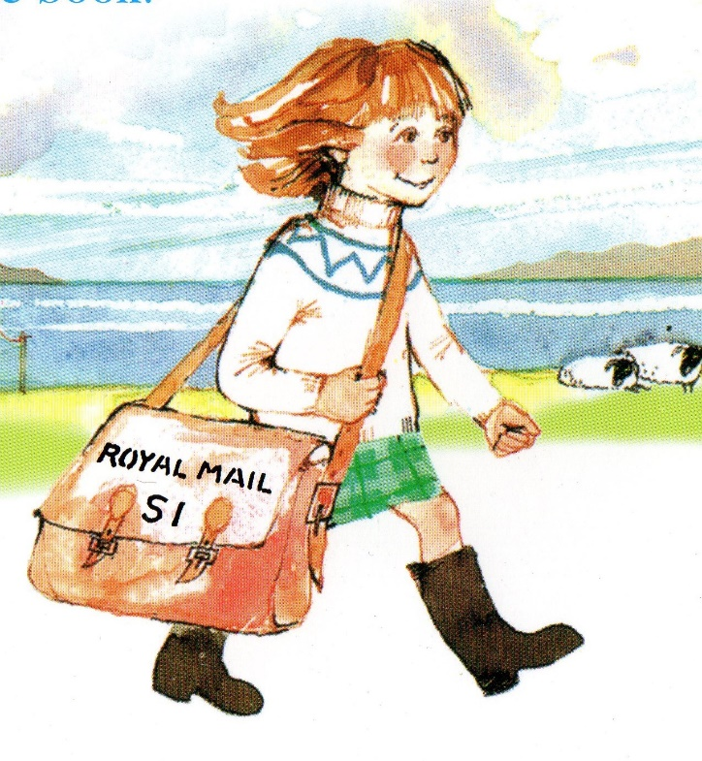The Katie Morag Quiz

1. Where does Katie Morag live?
2. What are her grannies called?
3. What job do her parents do?
4. What is her little brother called?
5. Can you remember the 4 items of mail that she mixed up in Katie Morag delivers the mail?
6. Why were her parents bad-tempered in the story?
7. What three things did Katie Morag and her grannie do to get Alecina ready for the show in Katie Morag and the Two Grandmothers?
8. In Katie Morag and the Big Boy Cousins, name three of the boys.
9. What was the naughty game they played called?
10. Name the three things they had at the barbecue.

Answers

1. Struay
2. Grannie Island and Grannie Mainland
3. They work at a post office.
4. Liam
5. Artists brushes, paintbrushes, fishing hooks, seeds
6. Liam was cutting a tooth
7. They washed her in the bath, they blow dried her, they brushed and curled her hair and they put perfume on her.
8. Hector, Archie, Jamie, Dougal, Murdo Iain
9. Chickenelly
10. Fried tatties, beans, marshmallows