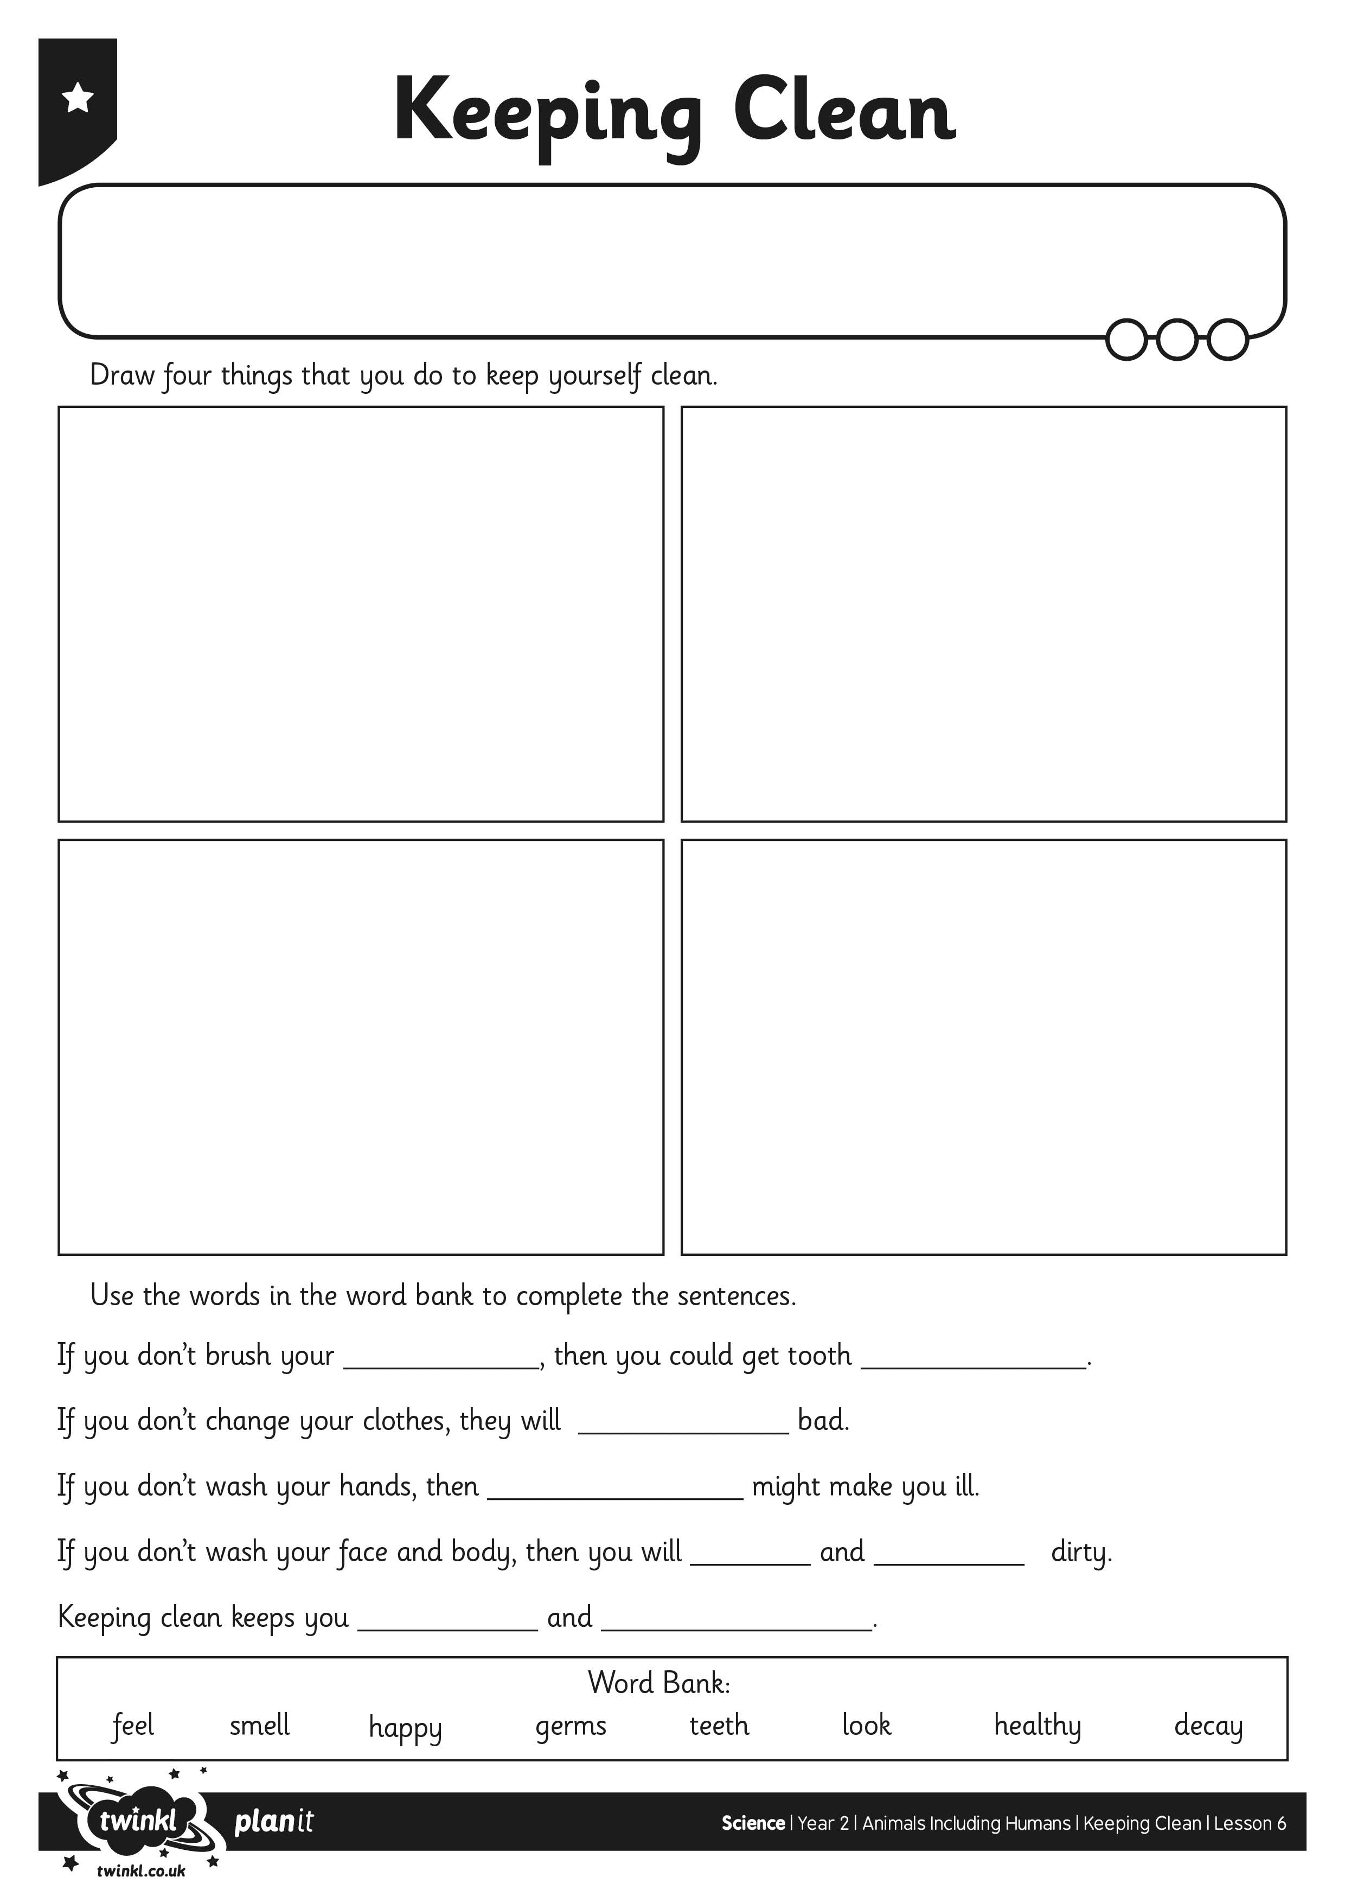
I can describe how and why to keep myself clean.
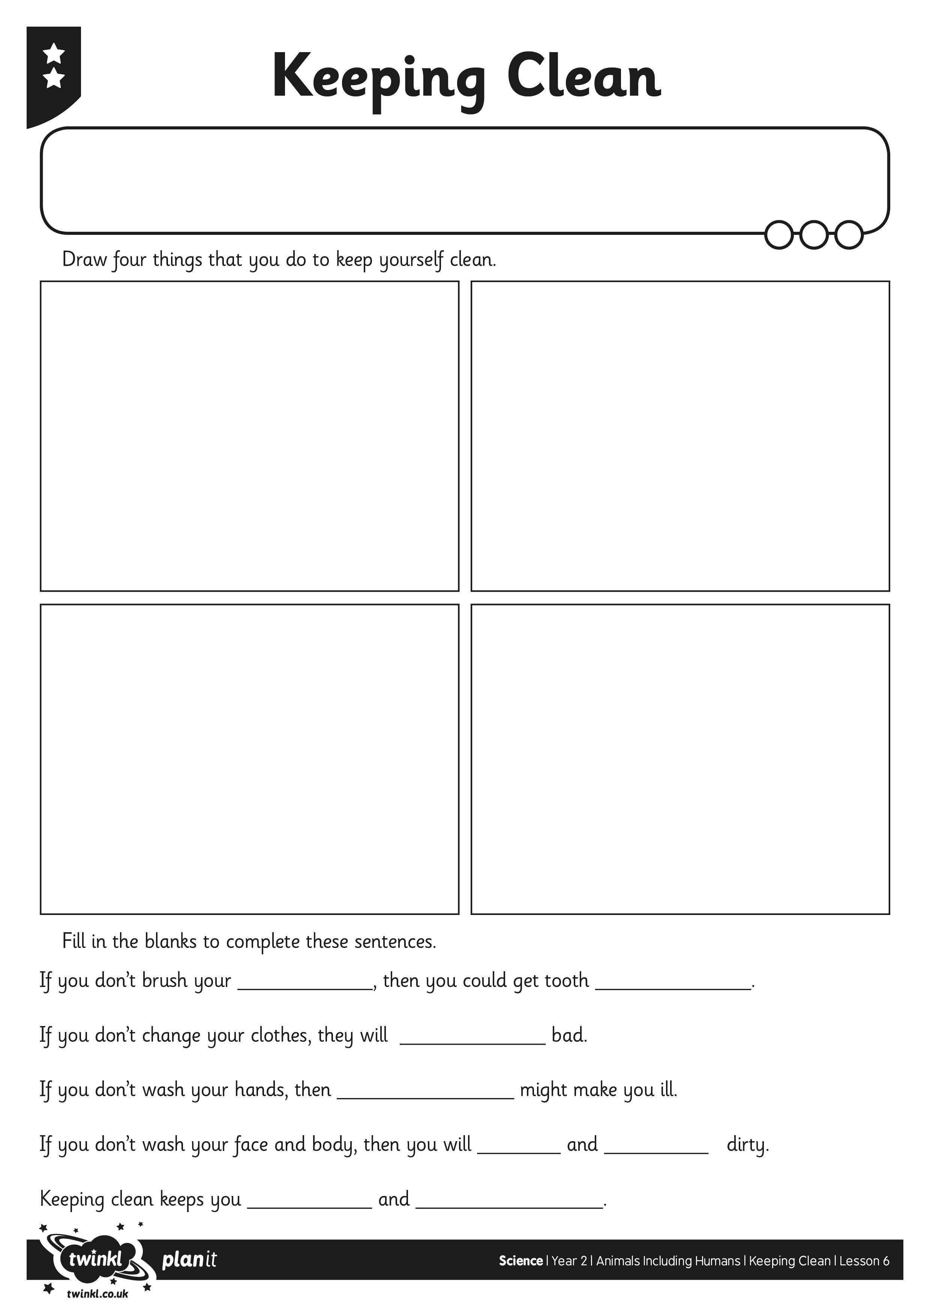
I can describe how and why to keep myself clean.
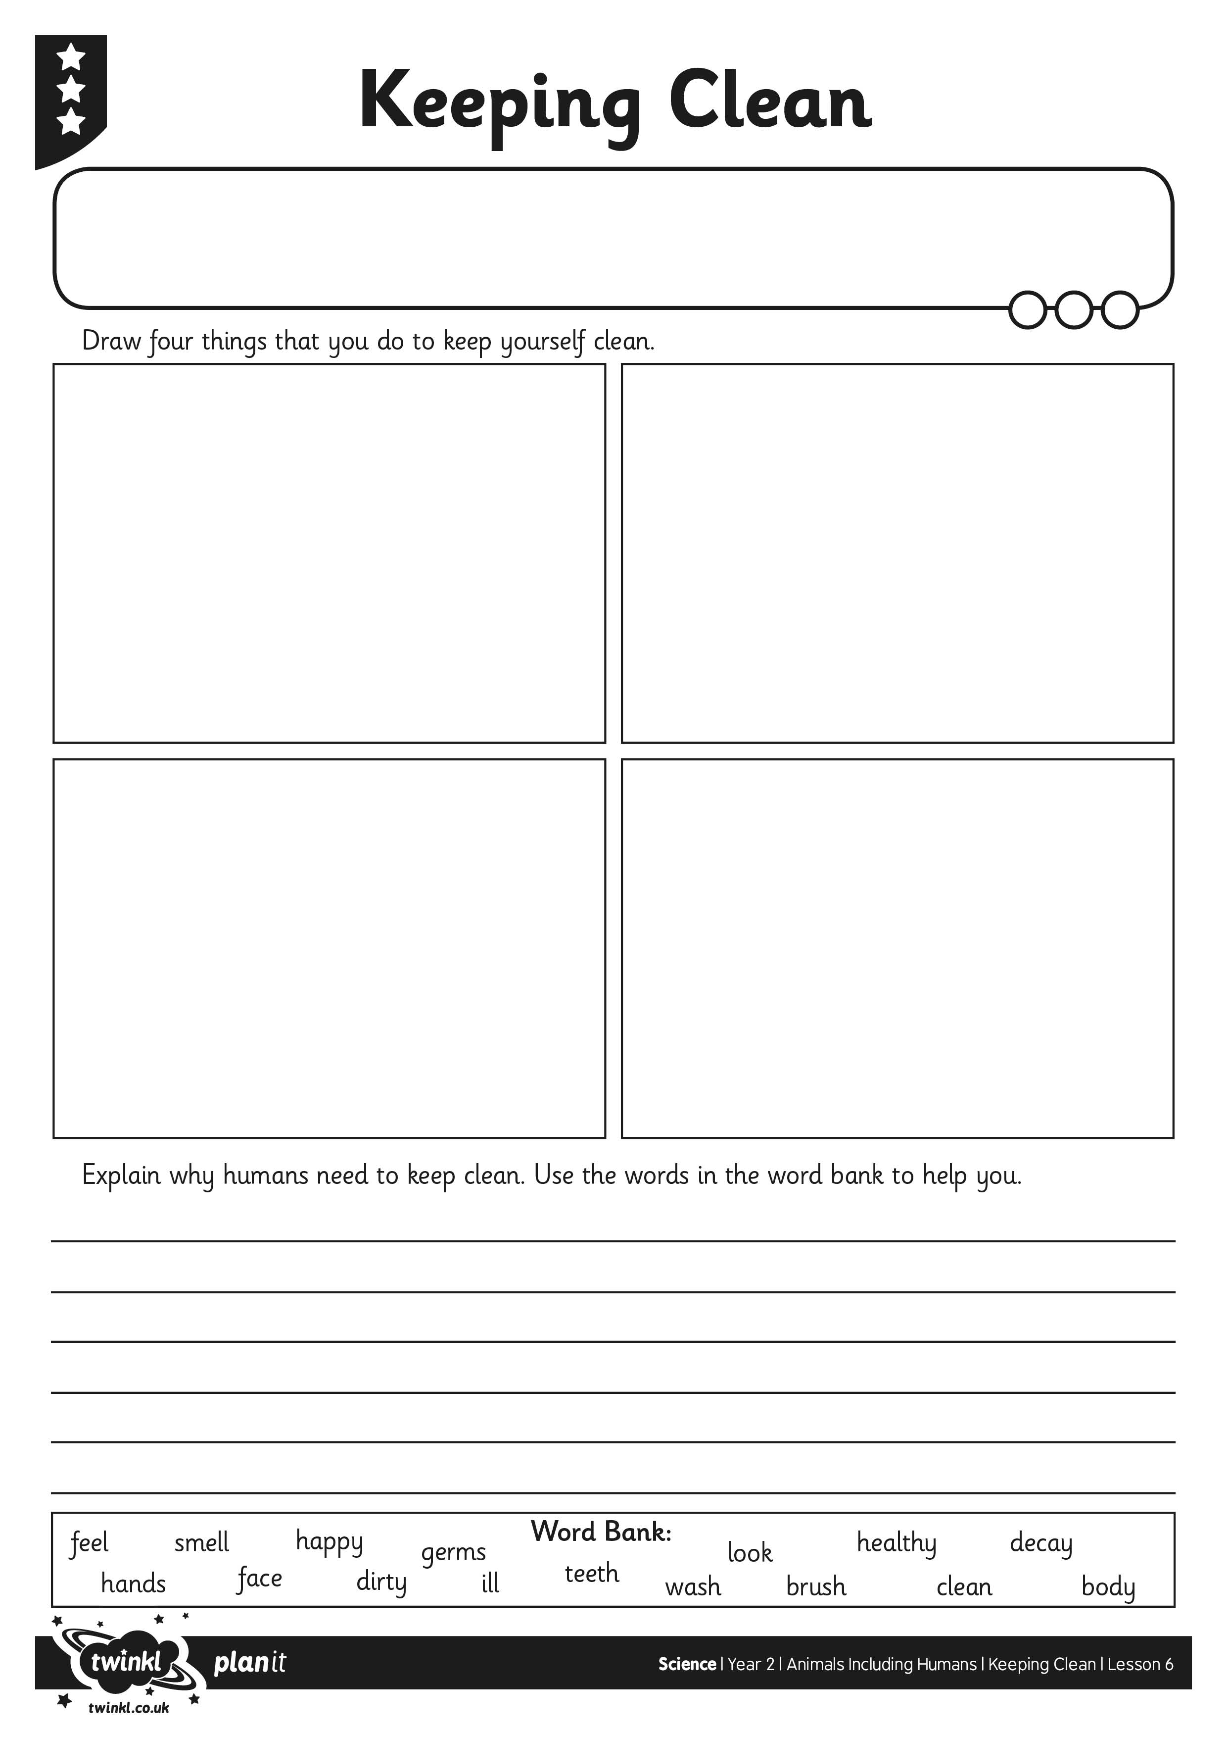
I can describe how and why to keep myself clean.

