Lesson | Topic | Activity | Ideas
1 | Living things | Life cycle project  Draw the life cycle of a mammal, an amphibian, a reptile, an insect and a bird. Draw them in a circular shape like:  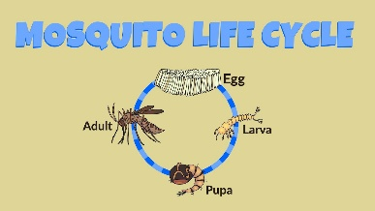  Write about how they are different from one another. You may want to use a Venn diagram to do this.  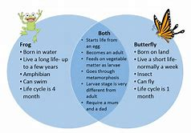 | https://www.bbc.co.uk/bitesize/subjects/z2pfb9q  Read the learner guides and watch the class clips. You may also want to do your own research online.  You can lay this task out as you wish. You may want to create a word document or Power point. Alternatively, make a poster or just write it on paper. Try to include drawings or tracings. Always draw in pencil and try to label pictures with a neat ruled line. Try to use as much scientific vocabulary as you can.  Key facts  Mammals – have hair, feed their young with milk, give birth to live young. E.g. dogs, giraffe, lions, otters.  Amphibians – lay eggs often in jelly, can take in oxygen through their skin when under water or through their lungs when on land, have a waxy skin, warm blooded. E.g. frogs, toads, newts.  Birds – have feathers, some can fly but not all, lay oval eggs, warm-blooded. E.g. Blue tit, penguin, eagle.  Reptile – has a rough skin, lays round eggs, cold-blooded. E.g. turtles, chameleon, bearded dragon.  Insects – have 6 legs, some fly, 3 body parts (head, thorax, abdomen). E.g. Ladybird, fly, butterfly.
2 | Living things | Habitat project  Learn about 4 different habitats. Choose from: the seaside, forests, deserts, rainforests, African Savannah, jungles, the arctic, inner city, inside our homes, wetlands, wild flower meadows.  What animals live there?  What plants are there?  What is the terrain like?  Do people live there? Is it developed?  Can you locate some on a map?  How are the animals adapted to live live there?  What are the challenges of living in the habitat?  What is the climate like throughout the year?  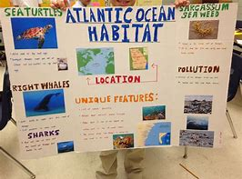  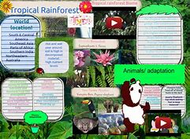 | Have a look at the BBC Bitesize Science website…  Read the learner guides and watch the class clips. You may also want to do your own research online.  You can lay this task out as you wish. You may want to create a word document or Power point. Alternatively, make a poster or just write it on paper. Try to include drawings or tracings. Always draw in pencil and try to label pictures with a neat ruled line. Try to use as much scientific vocabulary as you can.  You may want to draw a climate graph for the year in your habitat like:  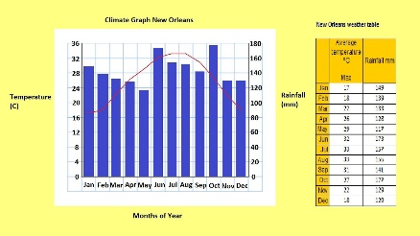  Try to find some good adjectives to describe the habitats.  You could extend this work to write a story set in each habitat or by thinking of endangered animals in each habitat.  Have you got any books you could read set in different habitats?
3 | Living things | Animal project  Learn about a selection of animals that you currently don’t know about.  Think about their:  - Classification – mammal, reptile, insect, bird, amphibian etc  - Life span  - Life cycle  - What are their young called?  - How big are they?  - How heavy are they?  - Do they live in groups or alone?  - What do they eat?  - Where do they live? | Click here for the BBC bitesize Science page on ‘animals’.  Read the learner guides and watch the class clips. You may also want to do your own research online.  Can you make some fact cards (either hand-written or on the computer)?  You might want to create a quiz on Kahoot.  You could make your own set of top trump cards.  You could create a spreadsheet on excel so you can sort them by size etc.  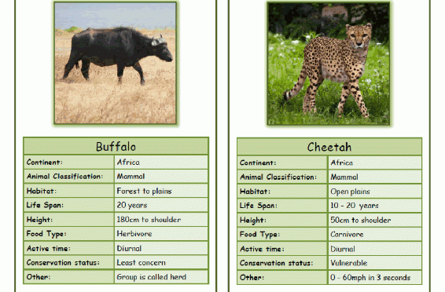
4 | Living things | Humans  You need to know about: how humans change as they get older, the circulatory system and the digestive system.  Also the impact that eating healthily and exercise has on the body and the things that can harm you – alcohol, cigarettes, e-cigarettes, prescription drugs used incorrectly, street drugs.  Knowing the names of the organs in the human body is important and what they do. | Click here for the BBC bitesize Science page on ‘humans’  Read the learner guides and watch the class clips. You may also want to do your own research online.  Search out all those science books you have been given as presents. Be creative so you are more likely to remember it. Alternatively, there are worksheets on Twinkl (use the password you were given for the History topic on the railways).  https://www.twinkl.co.uk/search?term=human+body  