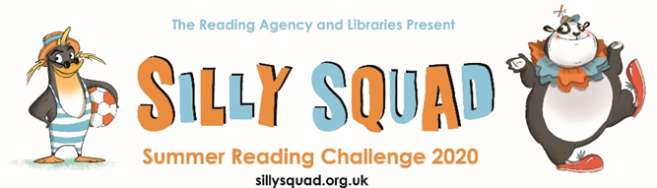

**15th June 2020**

**Summer Reading Challenge in Cumbria’s libraries**

The Summer Reading Challenge is an annual event in Cumbria County Council’s libraries over the school summer holidays. Aimed at 4 – 11 year olds, children are encouraged to read six (or more) books of their choice during the summer holidays, with collectable incentives and rewards, plus a certificate for every child who completes the Challenge.

This year, with the disruption caused by Covid-19 and the impact of social distancing on schools and public libraries, an all-new digital Summer Reading Challenge is launching, earlier than usual, to keep children reading over the summer and to support parents and carers with children at home.

Launching on 15th June, and running until September, the theme for the 2020 Challenge is “Silly Squad” – a celebration of funny books, happiness and laughter.

The Challenge website (www.sillysquad.org.uk) is free to access and is a place for children to rate and review their books and work towards their reading goal. It will also feature video content, games, quizzes, and digital and downloadable activities to incentivise and encourage children and their families to take part in the Challenge at home.

The library service’s BorrowBox platform offers families a wide range of children’s ebook and eaudiobook titles to support the challenge and these are FREE to download for library members. Anyone who is not a member of the library can join for free, and get instant access to the library service’s online resources.

Free downloadable ebooks and eaudiobooks: <https://www.cumbria.gov.uk/libraries/online_resources/ebooks_audiobooks.asp>

Free instant membership:

<https://www.cumbria.gov.uk/libraries/services/membserv.asp>

Free Summer Reading Challenge website: [www.sillysquad.org.uk](http://www.sillysquad.org.uk)