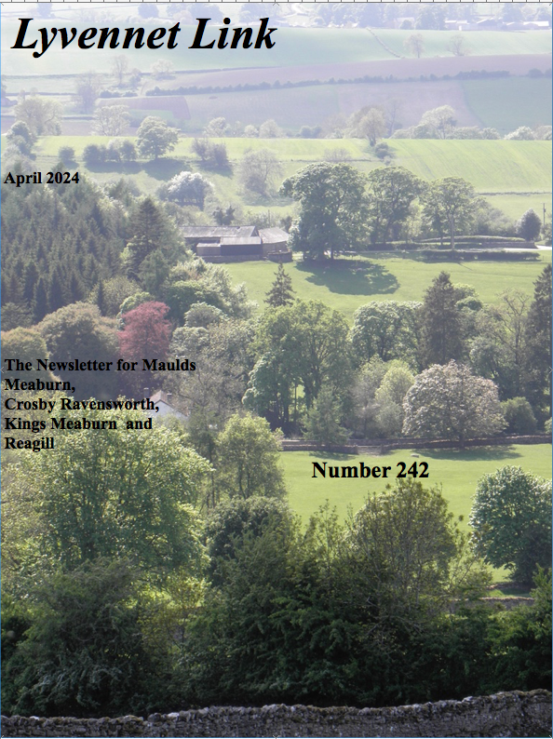
LYVENNET LINK

Next Issue - 1st May 2024
Copy deadline 25th April 2024

As you have probably gathered the Link may not be out by the 1st of the month. I would encourage anyone advertising events early in the month to also put them in the previous issue.)

edited by Nick Thomas e-mail: nickthomas@macace.net

Articles and contributions etc., would be appreciated preferably by e-mail nickthomas@macace.net. Please send items as either text in the body of the email or as a word document. (apple-mac files acceptable)
Please do not send Microsoft publisher documents as I am unable to open them.

Parish Council Minutes.
Minutes of Parish Council meetings are available at:

www.crosbyravensworthparish.org.uk
Planning applications are available to view on the Yorkshire Dales planning portal here:
https://planning.agileapplications.co.uk/yorkshiredales

and on Westmorland and Furness Council's portal here:
https://eforms.eden.gov.uk/fastweb/search.asp

link to the agenda for the Crosby Ravensworth Parish Council Meeting on 8th April.

crosbyravensworthparish.org.uk/agendas

Services at your parish church of
St Lawrence
in April
[ other Benefice services can be found at
https://northwestmorland.church]

All welcome

Sunday April 7th Low Sunday 9.15 am Benefice Service of Holy Communion at Clifton/ Stephen Tudway
11.15am Cafe Church at Askham Village Hall/Stephen Tudway

Sunday April 14th 11.00am Holy Communion with Bishop James Bell

Sunday April 21st 6.00pm Evening Prayer with Revd Stephen Tudway preceded by our Annual Parochial Church Meeting at 4.30pm
[see note below]

Sunday April 28th 11.00am Holy Communion with Bishop James Bell

Sunday 21st April Annual Parochial Church Meeting [APCM] 4.30pm in Church

An occasion for you to hear what has been happening at your parish church of St Lawrence this last year, to vote for officers for 2024-25 if you are on the Electoral Roll [not the voting roll for Government but the church roll for Ecclesiastical ie Church stuff].
If you are not on the roll, you are still welcome to attend the APCM.
If you are not on our church roll, please consider signing the form at the back of church to become so.
We promise you will not be plagued with emails etc but we would then be able to include you in the overall total when we apply for grants: 'How many on the Electoral Roll?' is is one of the first questions we are asked. The more, the merrier, the happier.
Jill Winder is our Electoral Roll person [ 715 496] and will help you complete the form.

Notice for your diary
Sunday June 23rd 2024 is to be Open Gardens in our parish…...
kicking off with coffee and bacon rolls in MMVI, gardens to see then gravitate south to Crosby, to enjoy more gardens, Appleby Town Band and traditional Westmorland teas in CRVH from 2pm..
Full details on posters and in May Link.

......AND THE WINNERS OF KATIE’S FUNDRAISING EASTER RAFFLE WERE....


ROB & PENNIE’S (of MM) envelope was drawn out first and so they won the Simnel cake which they were delighted with; the bag of Easter goodies was won by JANE WILSON (of CR) and last but not least, the Easter planter was won by one of Katie’s learning support assistants at school, Mrs Davidson. The raffle alone raised £141.

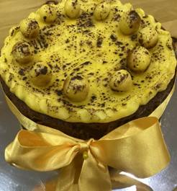
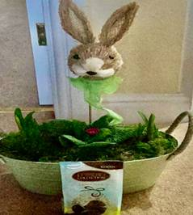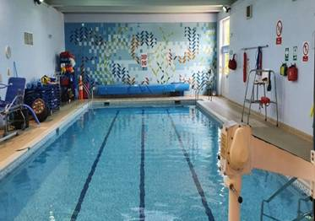

In addition, a number of people have also made donations (they know who they are and we are very grateful to them), and then there was £30 raised from the Mother’s Day treat boxes. The grand total comes to £383 which will be given to the Sandgate Hydrotherapy pool at Kendal where Katie goes to on a Friday night to help with her mobility and flexibility. We are so lucky to have this facility here in Cumbria and are pleased to support it. Thank you so much for supporting Katie and we hope that you managed to get an Easter treat box from one of the shelters as our way of saying ‘thank you’. Katie & Sarah x

Maulds Meaburn WhatsApp Group/email contact

Maulds Meaburn has a very successful Whats App group. It’s a good way to keep in touch with things that are going on, ask questions and ask for help etc. It is not ‘just for Meaburn residents’.

If you would like to join the group and are happy to put up with the occasional message not meant for the group… 😂 please email me with a mobile number and I will add you.

Alternatively, if you would like to receive a personal email outlining events at MMVI this is also an option.

Karen Asquith

hollyhowe15@me.com

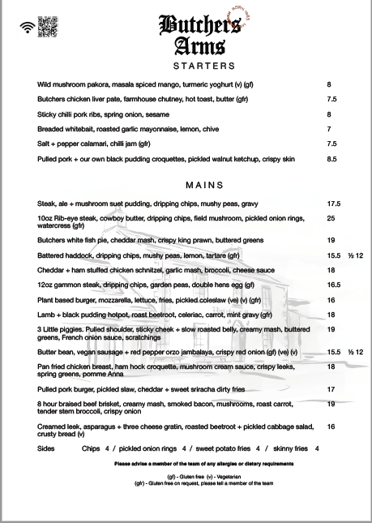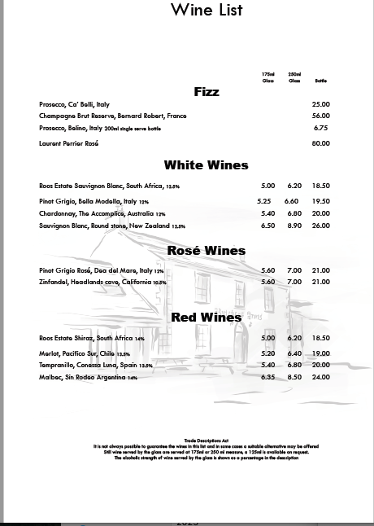
The Parish Annual Litter Pick
Will take place on
Saturday 6th of April
Pick up your equipment
From Crosby Ravensworth
Village Shelter
From 9-30 onwards.
Everyone welcome,
Last year some visitors joined us and enjoyed a free coffee with their lunch at the Butchers Arms!

Coffee and Bacon Sandwiches
or vegetarian option
served at the Butchers Arms
from 12 noon.
As a thank you from the Parish Council.
NEWS FROM CROSBY RAVENSWORTH C OF E SCHOOL.

The children are now enjoying their Easter break after what has been a busy end to the term.

Celebrating World Book Day was a great success. We even got our photo of the children and staff in their amazing costumes in the Herald! We had also encouraged the children to send in photos of them reading in unusual places and we received some great ones, such as reading whilst sat on a huge pile of logs, reading whilst crossing the river on stepping stones, reading whilst sat outside a bedroom window (not quite on the roof!), even reading to a cow and reading underwater!


The Easter Community Lunch was a sell out and those lucky enough to get a ticket tucked in to a two course delicious lunch prepared by Freda. The children then entertained parents and visitors with music (helped by Carolyn) and showed off their Easter bonnets. There was also a `decorate an egg` competition. Those who attended described it as the `loveliest of afternoons`.

Children in class 1 got to learn about the work which firefighters do when a fire engine visited school (by arrangement rather than an emergency). The children enjoyed putting the special helmets on and using the water hose. They also got to see inside the fire engine and look at some of the other equipment firefighters use.

Children in Class 2 have been looking at how artists use art to convey messages, from Ancient Maya to modern day street art. They have explored imagery, symbols, expressive mark making amongst other techniques used and then went on to create their own powerful drawings to make their voices heard. Just one example......

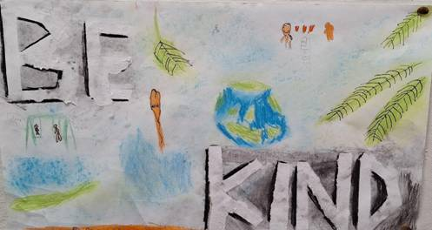

Then just before the end of term, the older children went to Hawse End to join other local schools on a residential trip. After mastering making their own bed, they did lots of activities, such as climbing Catbells, ghyll scrambling, a night walk alongside Derwent Water and archery to name but a few.

So, after the break, we will be in the summer term with more exciting opportunities planned.....the children in class 2 have a rugby session/tournament at Upper Eden Rugby Club to look forward to.

Don’t forget to find us and ‘like´ us on facebook so you can keep up to date with pictures from these and many other events during the year. We also have a website. If you have, or know of someone who has a child interested in joining our school, then please contact us on 01931 715265 to arrange a visit.

Our next ‘Pop in and Play’ is on Monday 20th May. All children currently not in school or pre-school, from birth up to 5 years are welcome to join from 9.30am until 10.30am for fun and games. Please phone on 01931 715265 to let us know if you’d like to come. Parents must accompany children. Please do pass on the message to anyone who you think might also like to know. This session gives you the opportunity to visit our fantastic school and meet the staff and pupils, whilst taking advantage of our terrific early years provision and your little ones can enjoy fun filled activities.

So until next month........................…
Maulds Meaburn Village Institute

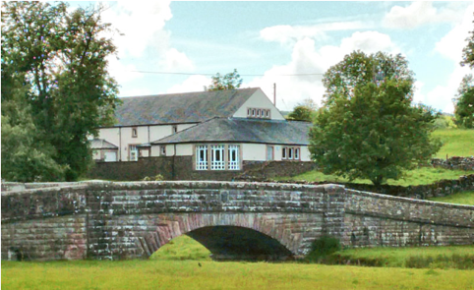

Regular Activities

Mondays…

9.30-11.30am Badminton in the main hall. Newcomers of all abilities including beginners, are always welcome.

2-4pm (apart from public bank holidays) the Post Office provides an outreach service, saving you a trip to Appleby/Penrith.

Tuesdays…

On the second Tuesday of the month, Book Club meets between 10.30am and midday.

On the fourth Tuesday of the month, Yarn Group meets between 10.30am and midday. Bring along your latest project whether that be knitting, crocheting ,sewing, embroidery, tapestry, whatever your craft may be.

The first WEDNESDAY of the month is Coffee Morning, 10.30am- midday. All welcome.

Thursdays…

Meeting of the Wine Group (meets bi-monthly) 7pm onwards. New members always welcome-come along to see what it’s like. Please contact Philippa for more info Philippa.Cordingley@curee.co.uk

Fridays…

The Gather Inn happens on the second Friday of the month, usually from 7pm for a ‘drop in for a drink and a chat’. Occasional ‘extras’ are advertised. The bar is open and the games are out!

Coming up in April…

Coffee morning on Wednesday 3rd April 10.30am until midday

Gather Inn QUIZ on Friday 12th April, 7pm start (doors open 6.30pm) with sandwiches and wedges (see poster below)

Sarah Dunning talk, “Tebay, Rheged and the Westmorland Family Story” on Thursday 18th April, 7pm (bar open from 6.30pm)(see poster below)
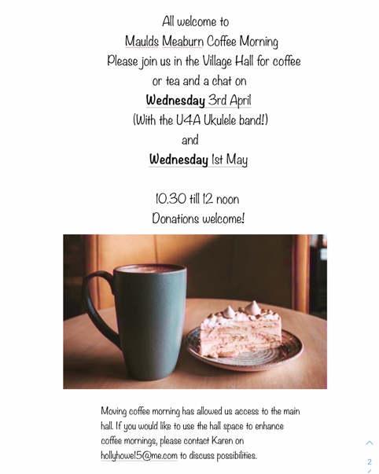
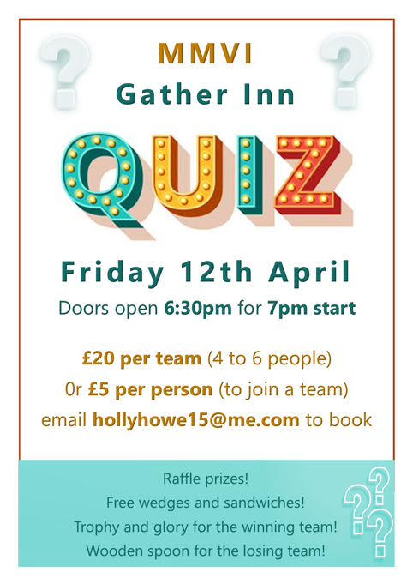

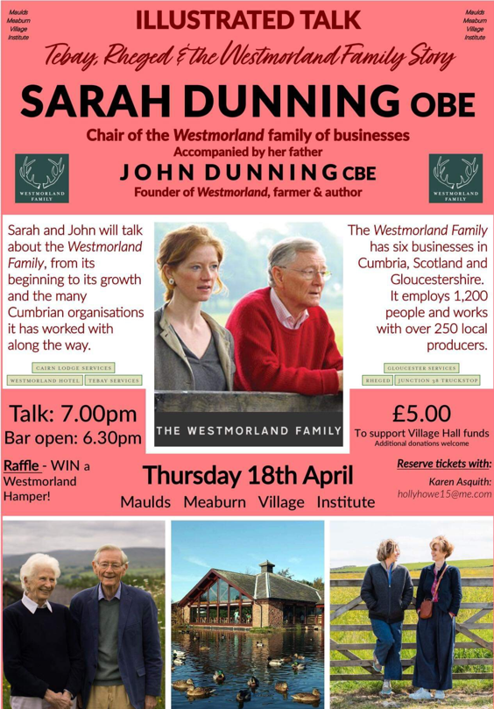

WINE GROUP
The next Meeting will be
Wednesday April 10th
7.00 pm at Maulds Meaburn Village Institute.

Theme Wines from Islands

If you like wine you are welcome.

We are a really friendly group who like drinking wine, no snobbishness, most of us don’t know much about wine, other than we like it.

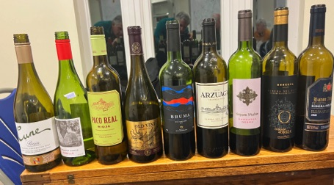

Meetings are usually the 2nd Wednesday or Thursday of alternate months, each person or couple bring a bottle of wine usually on a theme, make sure the wine labels are covered up, and a plate of appropriate nibbles. We then try to guess the wine and where it’s from and what we would like to eat with it. Than we reveal the bottle to see how wrong/right we were.
Occasionally we have a presentation from someone who does know about wine too.

For more information please contact

Pete Button tighmara@yahoo.co.uk

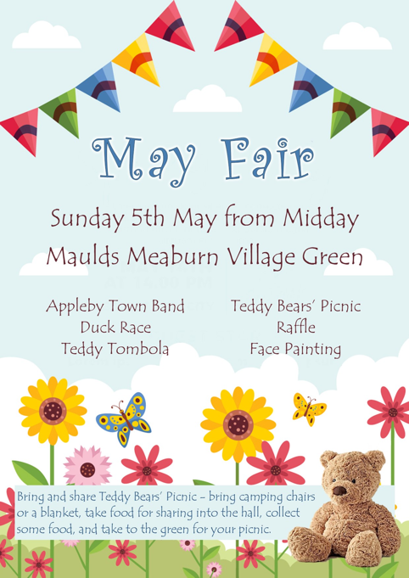

AIR AMBULANCE COLLECTION
ITEMS WHICH CAN BE DONATED FOR COLLECTION ARE:-
ALL CLOTHING (that can be sold and worn by others), SHOES IN PAIRS, COATS, BELTS, COSTUME JEWELLERY, BAGS.
USED STAMPS-please leave in a clear bag (or in the tub placed in CR/MM shelters)

Unfortunately we CANNOT ACCEPT :-
-Bedding, Duvets, Pillows or cushions
- Household textiles such as Curtains
-Books
-Toys/Games
-CDs/DVDs
-Bric-a brac
USE BLACK BIN BAGS YOU HAVE FOR ITEMS
PLEASE LEAVE BAGS ON THE FLOOR FOR COLLECTION. Items to be left before 9am on the day. 2ND WED OF EVERY MONTH
DATES ARE :- APRIL 10th, MAY 8TH JUNE 12TH JULY 10TH AUG 14TH
INFO KITTY 01931-715375 EMAIL kitty.s65@btinternet.com

